CS425 Project2 Report

Chunhei Yuen & Yichun Zhou

Shared Variables in Part1 with “coverage”:

pthread_mutex_t mutex;  
sem_t full, empty;  
int number = 0;   
int count, in, out;  
int buffer[0];  
void *consumer(void *param);  
void *producer(void *param);  
struct v {  
 int TID;

int BUFFER_SIZE;  
 int UPPER_LIMIT;  
 int NUM_PRODUCERS;  
 int NUM_CONSUMERS;  
};

Assume upper_limit == 500

|  |  |  |  |  |  |  |
| --- | --- | --- | --- | --- | --- | --- |
| Mutex | Buffer Size | | | | | |
|  | 10 | 20 | 30 | 40 | 50 | 100 |
| (1, 1) | 0.003970 | 0.003933 | 0.062041 | 0.078783 | 0.061735 | 0.161185 |
| (1, 5) | 0.014106 | 0.013709 | 0.080400 | 0.104082 | 0.080766 | 0.197547 |
| (5, 1) | 0.006754 | 0.004806 | 0.057950 | 0.082303 | 0.062564 | 0.161249 |
| (5, 5) | 0.015532 | 0.015290 | 0.084007 | 0.108486 | 0.082936 | 0.196190 |

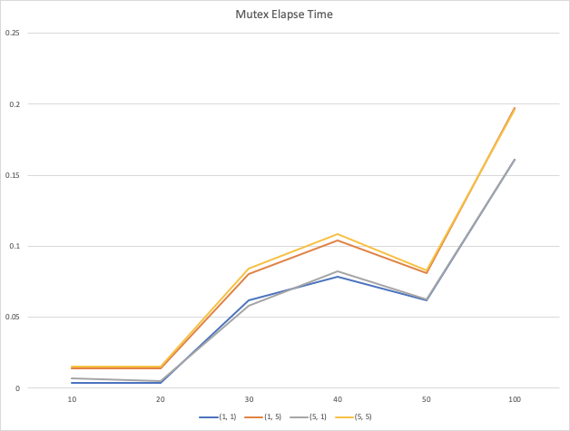

|  |  |  |  |  |  |  |
| --- | --- | --- | --- | --- | --- | --- |
| Spinlock | Buffer Size | | | | | |
|  | 10 | 20 | 30 | 40 | 50 | 100 |
| (1, 1) | 0.000049 | 0.000049 | 0.000054 | 0.000048 | 0.000038 | 0.000053 |
| (1, 5) | 0.000151 | 0.000155 | 0.000142 | 0.000157 | 0.000143 | 0.000151 |
| (5, 1) | 0.000154 | 0.000230 | 0.000140 | 0.000143 | 0.000175 | 0.000141 |
| (5, 5) | 0.000377 | 0.000447 | 0.000346 | 0.000465 | 0.000521 | 0.000332 |

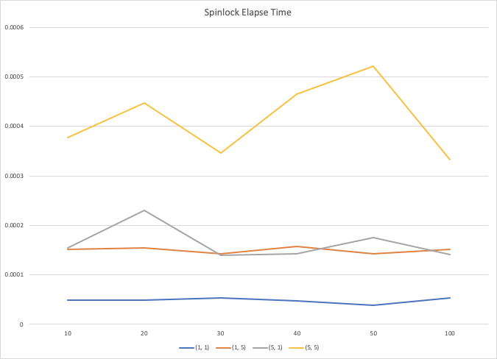

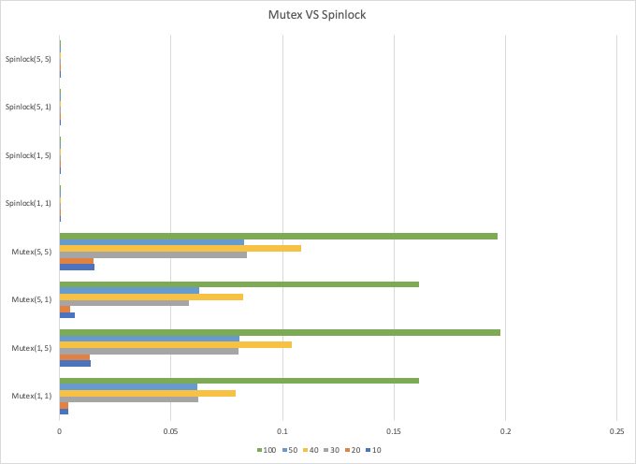

According to the graphs, we can see that spinlock run faster than mutex lock. In a multicore CPU, spinlock should run faster than using the mutex. Spinlock is an aggressive mutex, it keeps spinning until there have available resources, which means it keeps checking if the lock is available. This avoided the sleep and wake time, so we can see that spinlock has faster elapse time. However, when using a spinlock, it will use lots of CPU cycle. Sempahore mutex has to wait for the last thread finish to get the resources, it has the time to sleep and wake, and this increased the elapse time. But the advantage to using the mutex is to save more CPU cycle. And we think in one core CPU, we should avoid using Spinlock. Because in a single core CPU, if there has no resource then the lock will never unlock, it will just waste lots of resources.